DIGITAL ART

D.YASHASVINI

21311A05D2

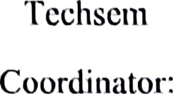

Dr. PRASANTA KUMAR SAHOO

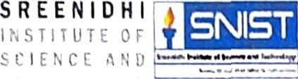

DEPARTMENT OF COMPUTER SCIENCE ENGINEERING

SREENIDHI INSTITUTE OF SCIENCE & TECHNOLOGY (AUTONOMOUS)

Yamnampet, Ghatkesar, R.R District,

Hyderabad-501301

( Affiliated to JNTU Hyderabad, and Approved by AICTE — New Delhi)

**ABSTRACT**

Digital Art Technology is constantly growing and changing our ways of living. It makes life easier at times, and more interesting too. When one would think of art in the past, usually computers and technology did not come to mind. Now because of modern technology, the digital age is uncovering vast ways to create amazing works of art through computer tools and software. Art is now digitally created and can appear unbelievable to the modern eye.

Not every piece of art requires a group to accomplish it. However, digital art usually involves multiple people who are either visually or technologically skilled. For example, a video game calls for technical proficiency along with visual components. GAMMA and Capstone allows students to venture into the video game work by collaborative team work. It is not necessary for every member to be professionals in both the technical and visual fields but it is critical for them to have an understanding.

The digital Art is the central point between Technology and Art with a great impact to new development on presentation and communication to viewers. This concern the application of digital technology and the use of article to give information through art work. The impact of technology within an arts context lies above all in the fact that the technology is used to beauty Viewers who see how technology is used, begin to realize that it can be used in creative and other ways than were intended.